ENGR 213 Midterm Finder
Concordia University | 2018–2026 | Studocu
An illustrated catalogue of midterms, solutions, practice papers and review aids found through your signed-in Studocu session. Checked October 20, 2026.

What was found
88 unique document listings were retained from 12 catalogue pages: all 8 pages of Practice materials and all 4 pages of Other Documents. 44 obvious wrong-course or pre-2018 midterm-related entries were excluded. These counts refer to listings, not distinct exams or verified exam sittings.
The screenshots show catalogue listing previews and metadata—not full exam pages. This document does not reproduce complete third-party exam papers or solutions. Use the clickable title of each entry to view the source through your own Studocu access.

How to read the years
A title year is only a lead unless a header was checked. An academic-year label such as 2022/2023 is not proof that an exam was held in 2022 or 2023. Entries without a title/header year are grouped by the first year of the catalogue label solely for navigation. Some are older papers re-uploaded under newer years; only clearly identified older papers could be removed.
Types are title-based classifications, not authentication by Concordia. “Study/review aid” may contain a paper despite its title. Studocu’s Mock exam / Summary / Quiz navigation tabs are not evidence of document type. Page counts below are the catalogue counts, not a guarantee of completeness. Different document IDs may reproduce the same exam.
Scope: a broad catalogue scan, not a guarantee of every ENGR 213 exam on Studocu. Other categories, unindexed documents, removed listings and future uploads may contain additional items. No exam PDFs were downloaded, and nothing was uploaded or republished on Studocu. Listing images combine browser screenshots and crops of browser-exported catalogue pages; some print captures retain Studocu navigation overlays, so the typed title and link are also supplied. One document-specific extraction (ID 27340666) encountered human verification; its internal date was not confirmed.
Navigation year | Listings | Evidence caution
2018 | 5 | Mix of title/header years and academic-year labels
2019 | 9 | Mix of title/header years and academic-year labels
2020 | 8 | Mix of title/header years and academic-year labels
2021 | 10 | Mix of title/header years and academic-year labels
2022 | 17 | Mix of title/header years and academic-year labels
2023 | 9 | Mix of title/header years and academic-year labels
2024 | 14 | Mix of title/header years and academic-year labels
2025 | 11 | Mix of title/header years and academic-year labels
2026 | 4 | Mix of title/header years and academic-year labels
Undated | 1 | Not assigned to 2018–2026; retained as a lead

Best dated starting points
2018: ENGR 213 Midterm 1 (2018) Differential Equations Q&A Solutions
Header checked: Fall 2018, October 19, 2018; Midterm Test 1, Section XX; Reinaldo Rodriguez. Viewer academic year 2017/2018 conflicts with the header. Catalogue lists 3 pages.
2019: Midterm Exam Solutions for ENGR 213 - Applied ODEs, Oct 25, 2019
Header checked: Fall 2019, October 25, 2019; solutions. Academic year 2019/2020 is consistent. Instructor not found.
2020: Midterm Solutions for ENGR 213: Applied Differential Equations - Fall 2020
Header checked: Fall 2020 SOLUTIONS; no specific day or instructor found. Academic year 2020/2021 is consistent.
2021: Midterm Exam - ENGR 213 - Applied Ordinary Differential Equations F2021
Header checked: Fall 2021, Monday October 25, 2021, Type A; Sam Eskandarian. Listed as the exam, not solutions. Academic year 2021/2022 is consistent.
2022: Midterm Exam Solutions for ENGR 213 Applied Differential Equations Summer 2022
Header checked: Summer 2022, May 26, 2022; M. Hazlett. Site academic-year label is 2022/2023. Title says solutions, but the visible header/instructions alone did not confirm solutions.
2023: Midterm Exam 2 Study Guide for ENGR 213 F23 by Marco Bertola
Title says ENGR 213 F23 (Fall 2023), Marco Bertola. Academic year 2023/2024. Exact date and instructor role were not independently visible in extracted header text; catalogue calls it a study guide.
2024: ENGR 213 Midterm II Solutions - Differential Equations (Nov 20, 2024)
Header checked: ENGR 213 Section V, Midterm II, November 20, 2024. Solutions; 4 pages indicated in viewer. Academic year 2024/2025 is consistent.
2025: 2025 Midterm Fall
Signed-in viewer header visually checked: ENGR 213, Monday October 6, Sections RA/RB; instructor Alexey Kokotov; 1 hour, closed book. Header does not print the year; title says Fall 2025 and metadata says 2025/2026. Catalogue lists 1 page.
2026: ENGR 213 JB Term Test 1 Solutions - March 20, 2026
Header checked: ENGR 213 JB Term Test 1, Version 2, March 20, 2026. Site academic-year label 2026/2027 conflicts with the March 2026 date. Catalogue lists 10 pages.
For 2023 the starting point is title-dated; its exact exam header/date was not verified. The 2025 header gives Monday October 6 but no year, so 2025 comes from the title and site metadata. The other starting points have at least a term/year visible in the checked header.

2018
5 listings. Year grouping is a navigation aid; read the evidence note for each entry.

1. ENGR 213 - Fall 2018 Midterm Exam Problems and Solutions
Open on Studocu • document 42890262
Type: Exam/solutions listing | Catalogue pages: 3 | Listed year/date: 2020/2021
Exam date and document contents not independently verified. Inclusion is based on the catalogue title and academic-year label.
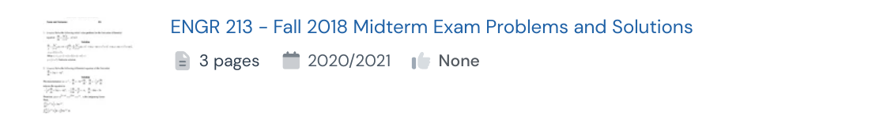
Catalogue source: Practice, page 6

2. ENGR 213 Midterm 1 (2018) Differential Equations Q&A Solutions
Open on Studocu • document 3251961
Type: Exam/solutions listing | Catalogue pages: 3 | Listed year/date: January 2018
Header checked: Fall 2018, October 19, 2018; Midterm Test 1, Section XX; Reinaldo Rodriguez. Viewer academic year 2017/2018 conflicts with the header. Catalogue lists 3 pages.
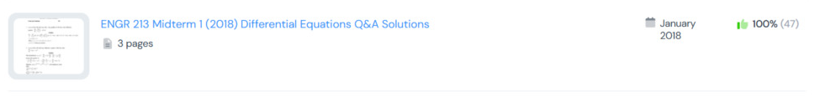
Catalogue source: Practice, page 1

3. ENGR 213 Midterm Exam Solutions - Differential Equations, Fall 2018
Open on Studocu • document 5367727
Type: Exam/solutions listing | Catalogue pages: 3 | Listed year/date: October 201
Exam date and document contents not independently verified. Inclusion is based on the catalogue title and academic-year label.
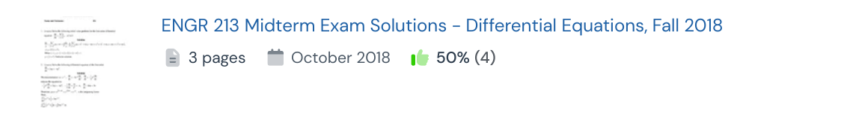
Catalogue source: Practice, page 7

4. ENGR 213 â€“ Midterm 2 (2018) Q&A on Differential Equations
Open on Studocu • document 3251952
Type: Exam/solutions listing | Catalogue pages: 4 | Listed year/date: January 201
Header checked: Fall 2018, November 16, 2018; Midterm Test 2, Section XX; Reinaldo Rodriguez. Viewer academic year 2017/2018 conflicts with the header. Catalogue lists 4 pages.
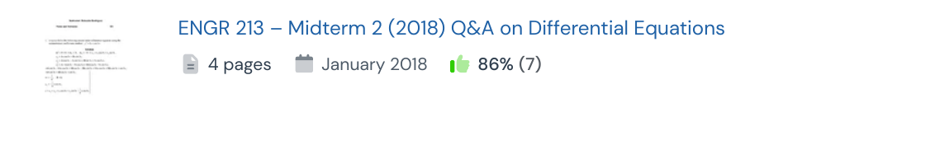
Catalogue source: Practice, page 2

5. ENGR-213 Midterm Practice Problems: Weeks 1-6 Overview
Open on Studocu • document 110923275
Type: Practice/sample | Catalogue pages: 18 | Listed year/date: 2018/2019
Exam date and document contents not independently verified. Inclusion is based on the catalogue title and academic-year label.
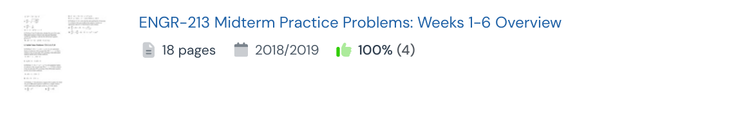
Catalogue source: Practice, page 1

2019
9 listings. Year grouping is a navigation aid; read the evidence note for each entry.

1. Midterm 3 Q&A Solutions 2019: Math Concepts and Problems
Open on Studocu • document 6054905
Type: Exam/solutions listing | Catalogue pages: 1 | Listed year/date: January 2019
Exam date and document contents not independently verified. Inclusion is based on the catalogue title and academic-year label.
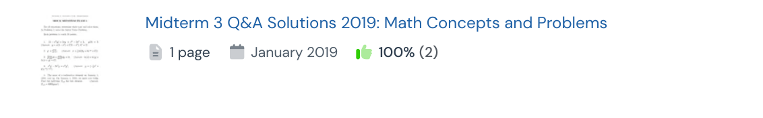
Catalogue source: Practice, page 2

2. Midterm Exam Solutions for ENGR 213 - Applied ODEs, Oct 25, 2019
Open on Studocu • document 6334955
Type: Exam/solutions listing | Catalogue pages: 5 | Listed year/date: October 2019
Header checked: Fall 2019, October 25, 2019; solutions. Academic year 2019/2020 is consistent. Instructor not found.
Catalogue source: Practice, page 1

3. Midterm Exam Solutions for ENGR 213: Applied ODEs, Fall 2019
Open on Studocu • document 6299217
Type: Exam/solutions listing | Catalogue pages: 5 | Listed year/date: October 201
Exam date and document contents not independently verified. Inclusion is based on the catalogue title and academic-year label.
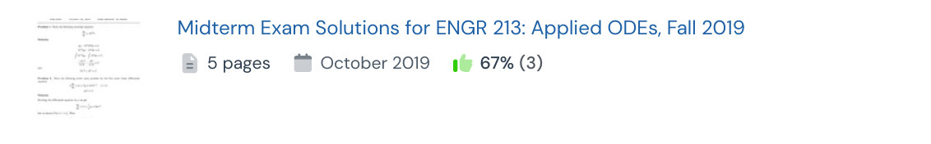
Catalogue source: Practice, page 3

4. Term Test 1 ENGR213 (with solutions
Open on Studocu • document 23999992
Type: Exam/solutions listing | Catalogue pages: 6 | Listed year/date: 2019/2020
Exam date and document contents not independently verified. Inclusion is based on the catalogue title and academic-year label.
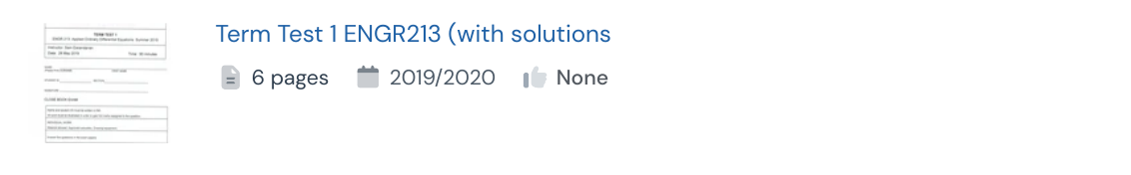
Catalogue source: Practice, page 6

5. ENGR 213 Midterm Exam Problems Winter 2019
Open on Studocu • document 27340666
Type: Midterm/term-test listing | Catalogue pages: 1 | Listed year/date: 2021/2022
Search lead identifies a Winter 2019 exam (February 15, 2019), despite original title/URL referring to 2021. Direct extraction encountered verification, so the internal date remains unverified in this review. Catalogue title itself says Winter 2019.
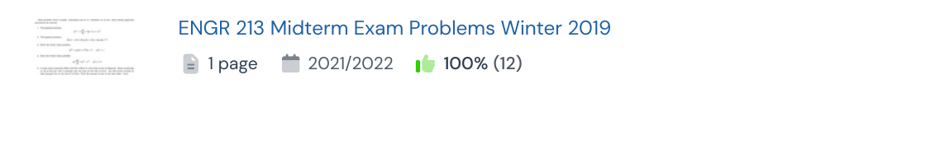
Catalogue source: Practice, page 1

6. Midterm Exam ENGR 213: Differential Equations Questions (Fall 2019)
Open on Studocu • document 10036775
Type: Midterm/term-test listing | Catalogue pages: 1 | Listed year/date: October 2019
Exam date and document contents not independently verified. Inclusion is based on the catalogue title and academic-year label.
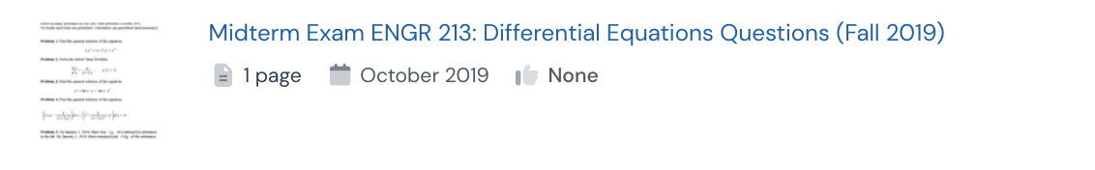
Catalogue source: Practice, page 7

7. Problems for Midterm
Open on Studocu • document 25671391
Type: Midterm/term-test listing | Catalogue pages: 3 | Listed year/date: 2019/2020
Exam date and document contents not independently verified. Inclusion is based on the catalogue title and academic-year label.
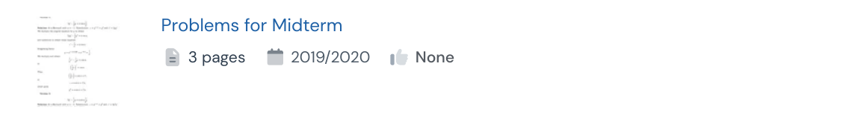
Catalogue source: Practice, page 6

8. Midterm Exam Review for EMAT 213 - Sample Questions and Solutions
Open on Studocu • document 175209119
Type: Study/review aid | Catalogue pages: 2 | Listed year/date: 2019/2020
Exam date and document contents not independently verified. Inclusion is based on the catalogue title and academic-year label.
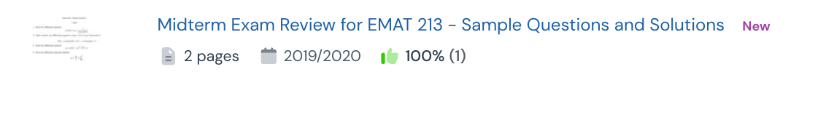
Catalogue source: Other, page 1

9. Problems for Midterm 1 Review
Open on Studocu • document 25671400
Type: Study/review aid | Catalogue pages: 2 | Listed year/date: 2019/2020
Exam date and document contents not independently verified. Inclusion is based on the catalogue title and academic-year label.
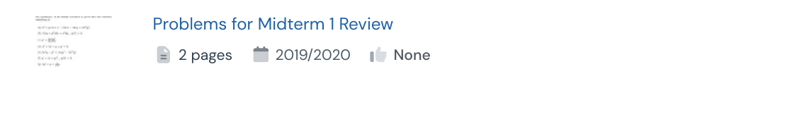
Catalogue source: Practice, page 6

2020
8 listings. Year grouping is a navigation aid; read the evidence note for each entry.

1. Midterm 12 August, questions and answers
Open on Studocu • document 11151263
Type: Exam/solutions listing | Catalogue pages: 7 | Listed year/date: August 2020
Exam date and document contents not independently verified. Inclusion is based on the catalogue title and academic-year label.
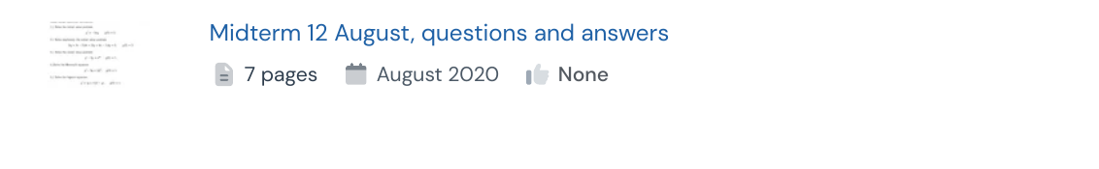
Catalogue source: Practice, page 7

2. Midterm 2020, answers
Open on Studocu • document 10196018
Type: Exam/solutions listing | Catalogue pages: 5 | Listed year/date: Invalid Date
Exam date and document contents not independently verified. Inclusion is based on the catalogue title and academic-year label.
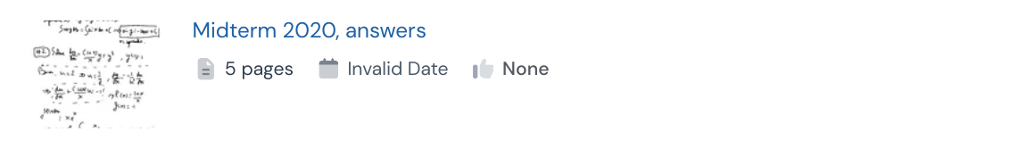
Catalogue source: Practice, page 7

3. Midterm 2020, questions and answers
Open on Studocu • document 10233572
Type: Exam/solutions listing | Catalogue pages: 6 | Listed year/date: Invalid Date
Exam date and document contents not independently verified. Inclusion is based on the catalogue title and academic-year label.
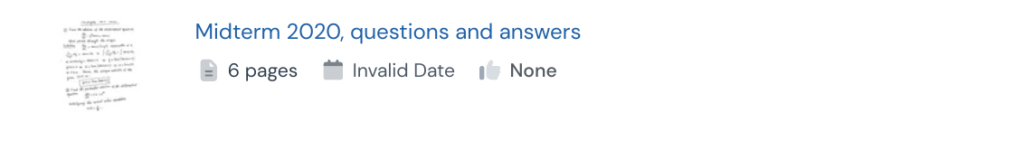
Catalogue source: Practice, page 7

4. Midterm 26 October 2020, questions and answers
Open on Studocu • document 9955095
Type: Exam/solutions listing | Catalogue pages: 8 | Listed year/date: October 2020
Exam date and document contents not independently verified. Inclusion is based on the catalogue title and academic-year label.
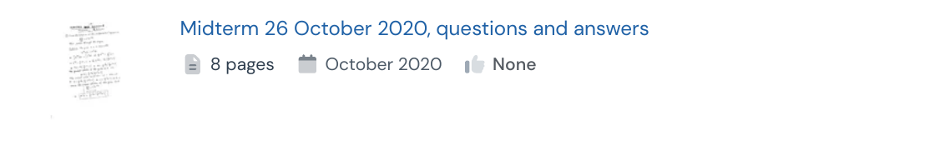
Catalogue source: Practice, page 7

5. Midterm Solutions for ENGR 213: Applied Differential Equations - Fall 2020
Open on Studocu • document 22084605
Type: Exam/solutions listing | Catalogue pages: 5 | Listed year/date: 2020/2021
Header checked: Fall 2020 SOLUTIONS; no specific day or instructor found. Academic year 2020/2021 is consistent.
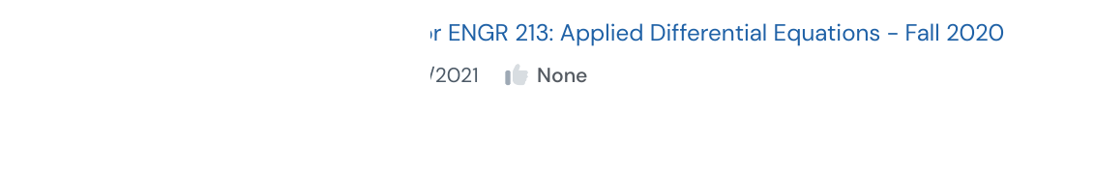
Catalogue source: Practice, page 7

6. Midterm Solutions for ENGR 213: Applied ODEs - Fall 2020
Open on Studocu • document 36512221
Type: Exam/solutions listing | Catalogue pages: 5 | Listed year/date: 2020/2021
Exam date and document contents not independently verified. Inclusion is based on the catalogue title and academic-year label.
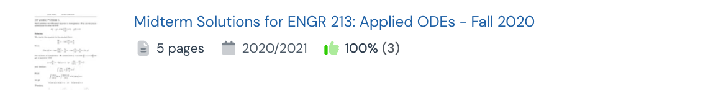
Catalogue source: Other, page 1

7. Midterm Exam ENGR 213: Applied Ordinary Differential Equations
Open on Studocu • document 9808352
Type: Midterm/term-test listing | Catalogue pages: 2 | Listed year/date: October 2020
Exam date and document contents not independently verified. Inclusion is based on the catalogue title and academic-year label.
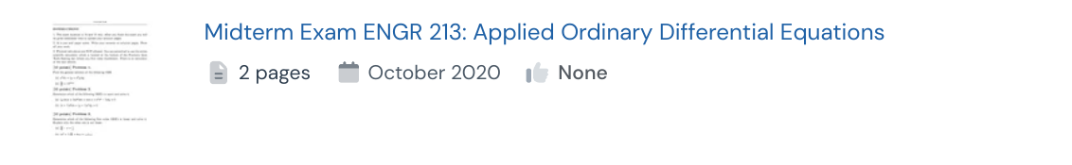
Catalogue source: Practice, page 7

8. Solutions to Sample Midterm Exam ENGR 213 on Differential Equations
Open on Studocu • document 14263718
Type: Practice/sample | Catalogue pages: 8 | Listed year/date: 2020/2021
Exam date and document contents not independently verified. Inclusion is based on the catalogue title and academic-year label.
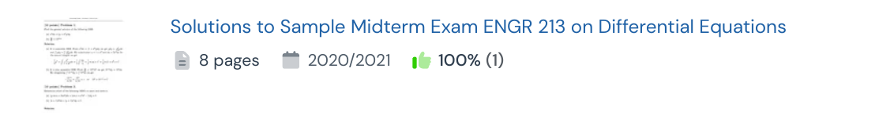
Catalogue source: Practice, page 3

2021
10 listings. Year grouping is a navigation aid; read the evidence note for each entry.

1. ENGR 213 Midterm Exam Solutions: Applied Ordinary Differential Equations
Open on Studocu • document 23863478
Type: Exam/solutions listing | Catalogue pages: 7 | Listed year/date: 2021/2022
Exam date and document contents not independently verified. Inclusion is based on the catalogue title and academic-year label.
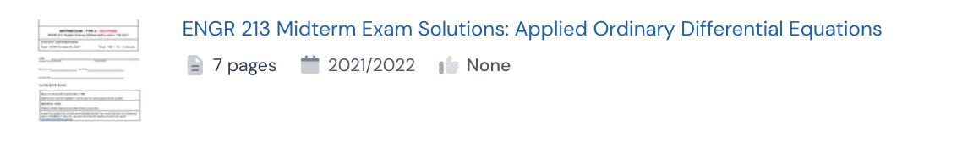
Catalogue source: Practice, page 6

2. ENGR 213 Midterm F2021 Type A Exam Solutions and Walkthrough
Open on Studocu • document 107735724
Type: Exam/solutions listing | Catalogue pages: 8 | Listed year/date: 2021/2022
Title identifies Fall 2021 Type A solutions; companion upload to the Type A exam. Not a separately verified exam sitting.
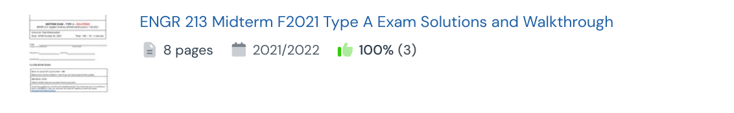
Catalogue source: Practice, page 2

3. Midterm Exam Solutions for ENGR 213 F2021 - Type B
Open on Studocu • document 121924475
Type: Exam/solutions listing | Catalogue pages: 8 | Listed year/date: 2021/2022
Exam date and document contents not independently verified. Inclusion is based on the catalogue title and academic-year label.
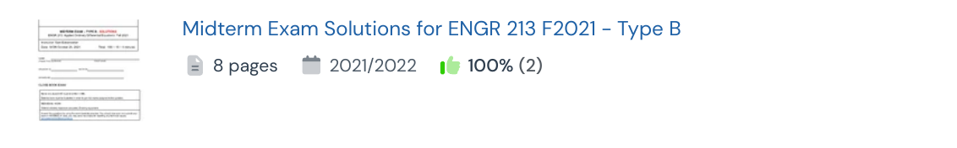
Catalogue source: Practice, page 2

4. ENGR 213 Midterm
Open on Studocu • document 153271370
Type: Midterm/term-test listing | Catalogue pages: 5 | Listed year/date: 2021/2022
Exam date and document contents not independently verified. Inclusion is based on the catalogue title and academic-year label.

Catalogue source: Practice, page 1

5. Midterm Exam - ENGR 213 - Applied Ordinary Differential Equations F2021
Open on Studocu • document 107735693
Type: Midterm/term-test listing | Catalogue pages: 3 | Listed year/date: 2021/2022
Header checked: Fall 2021, Monday October 25, 2021, Type A; Sam Eskandarian. Listed as the exam, not solutions. Academic year 2021/2022 is consistent.
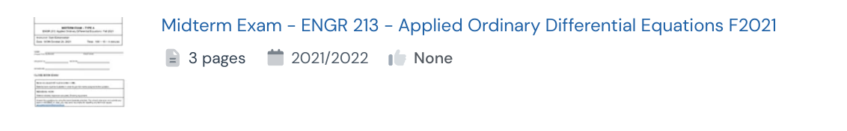
Catalogue source: Practice, page 5

6. Midterm engr213
Open on Studocu • document 20507249
Type: Midterm/term-test listing | Catalogue pages: 4 | Listed year/date: 2021/2022
Exam date and document contents not independently verified. Inclusion is based on the catalogue title and academic-year label.
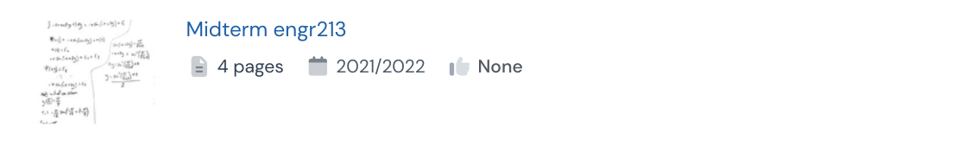
Catalogue source: Other, page 3

7. ENGR 213: Solutions to Practice Midterm Exam - Differential Equations
Open on Studocu • document 23680632
Type: Practice/sample | Catalogue pages: 7 | Listed year/date: 2021/2022
Exam date and document contents not independently verified. Inclusion is based on the catalogue title and academic-year label.

Catalogue source: Practice, page 7

8. Midterm 2 Sample A
Open on Studocu • document 51197181
Type: Practice/sample | Catalogue pages: 1 | Listed year/date: 2021/2022
Exam date and document contents not independently verified. Inclusion is based on the catalogue title and academic-year label.
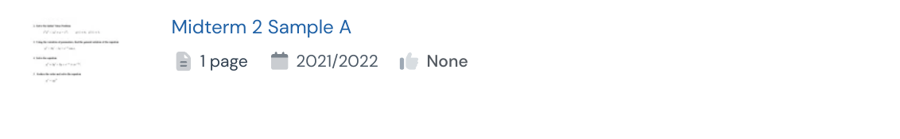
Catalogue source: Practice, page 5

9. Practice Midterm Exam for ENGR 213: Applied Ordinary Diff Eq
Open on Studocu • document 23510779
Type: Practice/sample | Catalogue pages: 3 | Listed year/date: 2021/2022
Exam date and document contents not independently verified. Inclusion is based on the catalogue title and academic-year label.
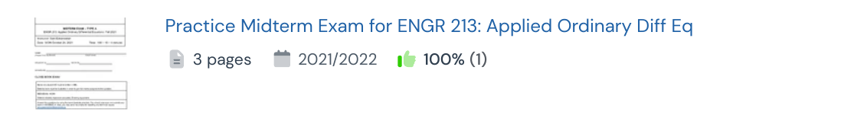
Catalogue source: Practice, page 3

10. ENGR 213 Midterm Exam Formula Sheet - Key Equations and Concepts
Open on Studocu • document 48674389
Type: Study/review aid | Catalogue pages: 2 | Listed year/date: 2021/2022
Exam date and document contents not independently verified. Inclusion is based on the catalogue title and academic-year label.
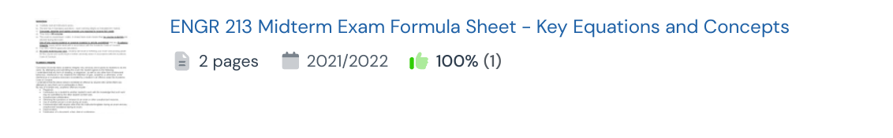
Catalogue source: Other, page 1

2022
17 listings. Year grouping is a navigation aid; read the evidence note for each entry.

1. ENGR213-Midterm 1 Problems and Solutions Overview
Open on Studocu • document 74821901
Type: Exam/solutions listing | Catalogue pages: 1 | Listed year/date: 2022/202
Exam date and document contents not independently verified. Inclusion is based on the catalogue title and academic-year label.
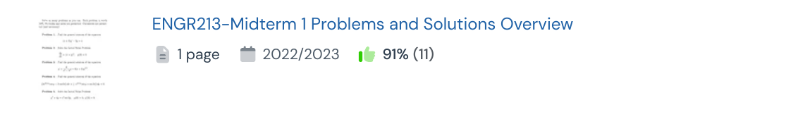
Catalogue source: Practice, page 1

2. ENGR213-Midterm 1b Problem Solutions and General Guidelines
Open on Studocu • document 74821924
Type: Exam/solutions listing | Catalogue pages: 1 | Listed year/date: 2022/2023
Exam date and document contents not independently verified. Inclusion is based on the catalogue title and academic-year label.
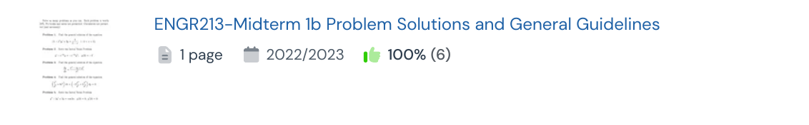
Catalogue source: Practice, page 1

3. ENGR213-Midterm 2 - Exam Problems and Solutions Summary
Open on Studocu • document 116179280
Type: Exam/solutions listing | Catalogue pages: 1 | Listed year/date: 2022/202
Exam date and document contents not independently verified. Inclusion is based on the catalogue title and academic-year label.
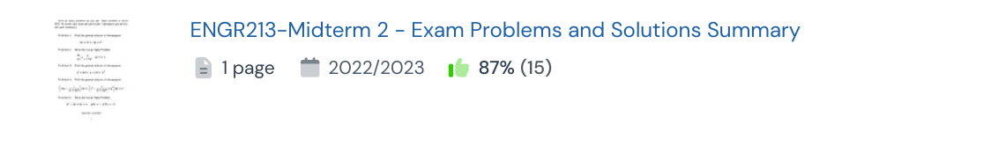
Catalogue source: Other, page 1

4. Emre Engr213 Midterm 2 2022 LRC Circuit Charge Solution
Open on Studocu • document 47908307
Type: Exam/solutions listing | Catalogue pages: 1 | Listed year/date: 2022/2023
Exam date and document contents not independently verified. Inclusion is based on the catalogue title and academic-year label.
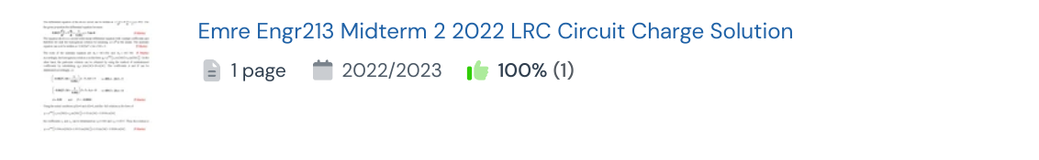
Catalogue source: Other, page 1

5. Midterm Exam Solutions ENGR 213: Applied ODEs Winter 2022
Open on Studocu • document 36325935
Type: Exam/solutions listing | Catalogue pages: 10 | Listed year/date: 2021/2022
Header says Winter 2022 and Dr. Sam Eskandarian, but the date line is extracted as Friday February 25, 2021. Preserve the conflicting year; do not silently correct it. Catalogue lists 10 pages.
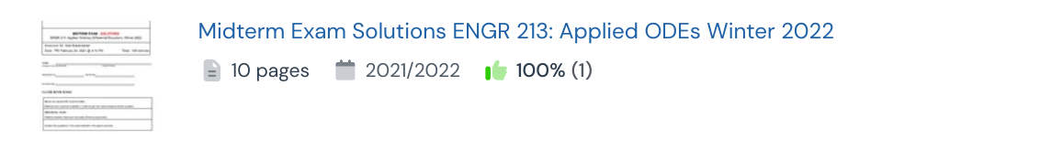
Catalogue source: Practice, page 3

6. Midterm Exam Solutions for ENGR 213 Applied Differential Equations Summer 2022
Open on Studocu • document 29414506
Type: Exam/solutions listing | Catalogue pages: 7 | Listed year/date: 2022/2023
Header checked: Summer 2022, May 26, 2022; M. Hazlett. Site academic-year label is 2022/2023. Title says solutions, but the visible header/instructions alone did not confirm solutions.
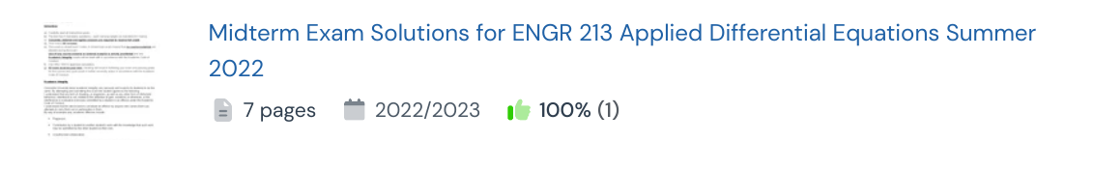
Catalogue source: Other, page 1

7. ENGR213 Midterm 1: Applied Advanced Calculus Test Problems
Open on Studocu • document 103038354
Type: Midterm/term-test listing | Catalogue pages: 1 | Listed year/date: 2022/2023
No exam date or instructor visible. Catalogue academic year 2022/2023 only. Header uses Applied Advanced Calculus, while the course category is Applied Ordinary Differential Equations; verify suitability.
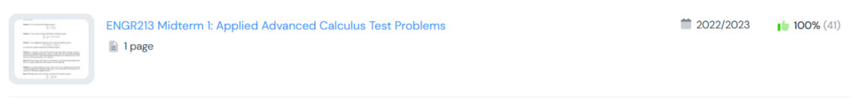
Catalogue source: Practice, page 1

8. ENGR 213 - Practice Midterm 2: Applied Advanced Calculus Test 2
Open on Studocu • document 106659352
Type: Practice/sample | Catalogue pages: 1 | Listed year/date: 2022/2023
Exam date and document contents not independently verified. Inclusion is based on the catalogue title and academic-year label.
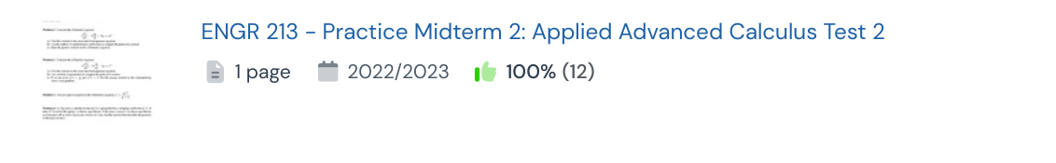
Catalogue source: Practice, page 1

9. ENGR 213 Midterm 1 Sample Questions - Ordinary Differential Equations
Open on Studocu • document 36600839
Type: Practice/sample | Catalogue pages: 1 | Listed year/date: 2022/2023
Exam date and document contents not independently verified. Inclusion is based on the catalogue title and academic-year label.
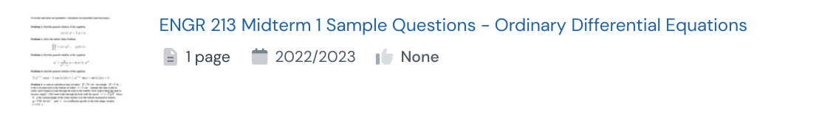
Catalogue source: Practice, page 6

10. Midterm 1 Sample 3 - ENGR 213 Ordinary Differential Equations
Open on Studocu • document 36600845
Type: Practice/sample | Catalogue pages: 1 | Listed year/date: 2022/2023
Exam date and document contents not independently verified. Inclusion is based on the catalogue title and academic-year label.
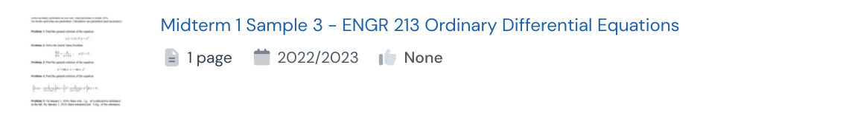
Catalogue source: Practice, page 6

11. Midterm 1 sample 1 solutions
Open on Studocu • document 36600834
Type: Practice/sample | Catalogue pages: 17 | Listed year/date: 2022/2023
Exam date and document contents not independently verified. Inclusion is based on the catalogue title and academic-year label.
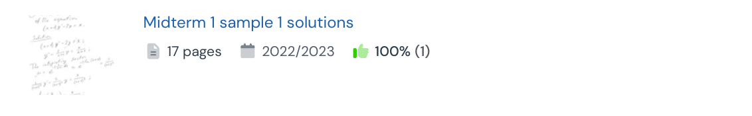
Catalogue source: Practice, page 3

12. Midterm 1 sample 3 solutions
Open on Studocu • document 36600849
Type: Practice/sample | Catalogue pages: 9 | Listed year/date: 2022/2023
Exam date and document contents not independently verified. Inclusion is based on the catalogue title and academic-year label.
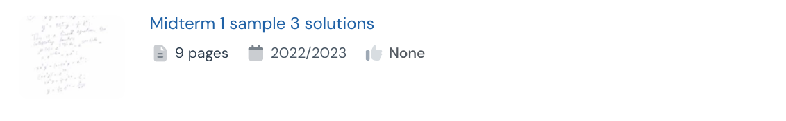
Catalogue source: Practice, page 6

13. Midterm Practice 2
Open on Studocu • document 30325726
Type: Practice/sample | Catalogue pages: 4 | Listed year/date: 2022/2023
Exam date and document contents not independently verified. Inclusion is based on the catalogue title and academic-year label.
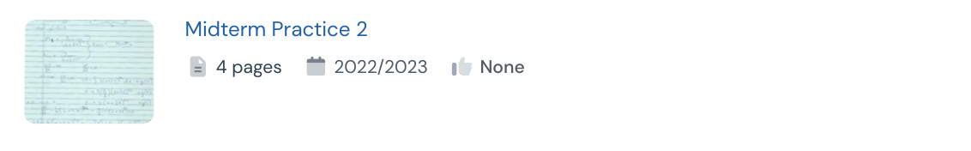
Catalogue source: Practice, page 6

14. ENGR 213 Midterm 1 Study Guide: Key Memory Aids and Questions
Open on Studocu • document 43154341
Type: Study/review aid | Catalogue pages: 9 | Listed year/date: 2022/2023
Exam date and document contents not independently verified. Inclusion is based on the catalogue title and academic-year label.
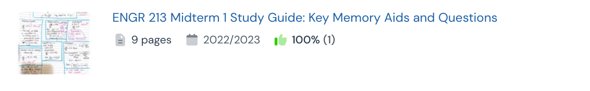
Catalogue source: Practice, page 3

15. ENGR 213 Midterm 2 Study Guide and Review Notes
Open on Studocu • document 54487617
Type: Study/review aid | Catalogue pages: 1 | Listed year/date: 2022/2023
Exam date and document contents not independently verified. Inclusion is based on the catalogue title and academic-year label.
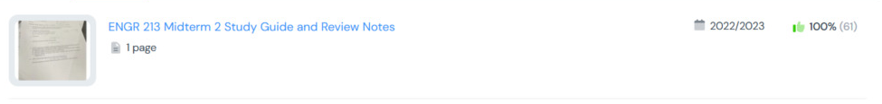
Catalogue source: Practice, page 1

16. ENGR213-Midterm 1 Study Guide: Practice Problems and Solutions
Open on Studocu • document 74821914
Type: Study/review aid | Catalogue pages: 1 | Listed year/date: 2022/202
Exam date and document contents not independently verified. Inclusion is based on the catalogue title and academic-year label.
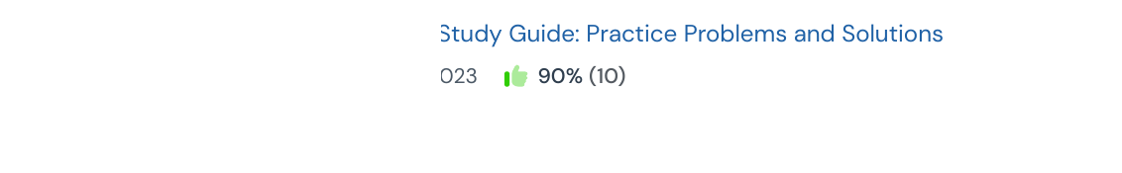
Catalogue source: Practice, page 2

17. Midterm Exam Instructions and Formulas for ENGR 213 - Summer 2022
Open on Studocu • document 30325713
Type: Study/review aid | Catalogue pages: 2 | Listed year/date: 2022/2023
Exam date and document contents not independently verified. Inclusion is based on the catalogue title and academic-year label.
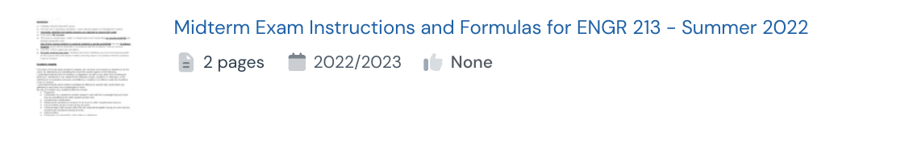
Catalogue source: Other, page 3

2023
9 listings. Year grouping is a navigation aid; read the evidence note for each entry.

1. Midterm I solutions
Open on Studocu • document 75254972
Type: Exam/solutions listing | Catalogue pages: 6 | Listed year/date: 2023/2024
Exam date and document contents not independently verified. Inclusion is based on the catalogue title and academic-year label.
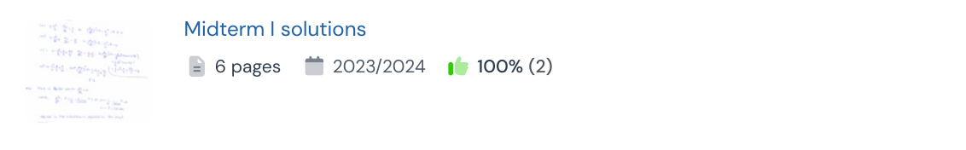
Catalogue source: Practice, page 2

2. ENGR 213 MIDTERM 1
Open on Studocu • document 88683620
Type: Midterm/term-test listing | Catalogue pages: 6 | Listed year/date: 2023/202
Exam date and document contents not independently verified. Inclusion is based on the catalogue title and academic-year label.
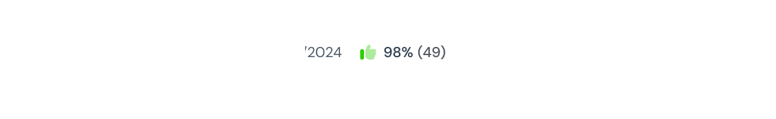
Catalogue source: Other, page 1

3. ENGR 213 Midterm Exam 1: Applied Ordinary Differential Equations
Open on Studocu • document 142280017
Type: Midterm/term-test listing | Catalogue pages: 1 | Listed year/date: 2023/2024
Exam date and document contents not independently verified. Inclusion is based on the catalogue title and academic-year label.
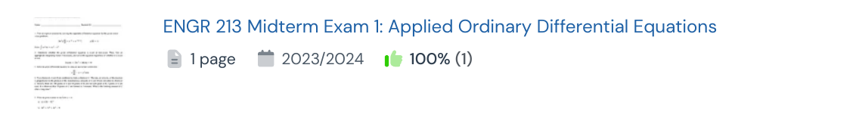
Catalogue source: Practice, page 3

4. ENGR 213 Midterm Exam 2: Applied Ordinary Differential Equations
Open on Studocu • document 145715006
Type: Midterm/term-test listing | Catalogue pages: 1 | Listed year/date: 2023/2024
Exam date and document contents not independently verified. Inclusion is based on the catalogue title and academic-year label.
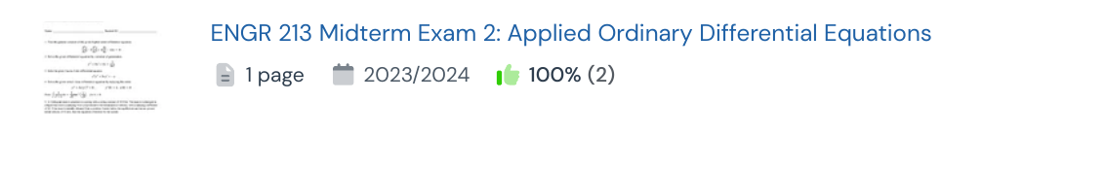
Catalogue source: Practice, page 2

5. Midterm 1 ENGR 213
Open on Studocu • document 78136013
Type: Midterm/term-test listing | Catalogue pages: 1 | Listed year/date: 2023/2024
Exam date and document contents not independently verified. Inclusion is based on the catalogue title and academic-year label.
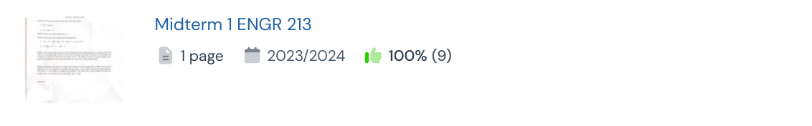
Catalogue source: Other, page 1

6. ENGR-213 Midterm 1 Sample Practice Exam Solutions
Open on Studocu • document 89125431
Type: Practice/sample | Catalogue pages: 8 | Listed year/date: 2023/2024
Exam date and document contents not independently verified. Inclusion is based on the catalogue title and academic-year label.
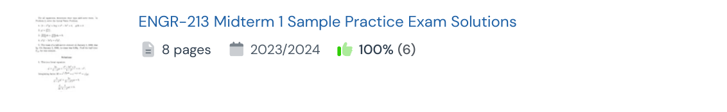
Catalogue source: Practice, page 1

7. ENGR-213J-Midterm 01 - Practice Exam with Dr. Ben Hersey
Open on Studocu • document 106855101
Type: Practice/sample | Catalogue pages: 2 | Listed year/date: 2023/2024
Exam date and document contents not independently verified. Inclusion is based on the catalogue title and academic-year label.
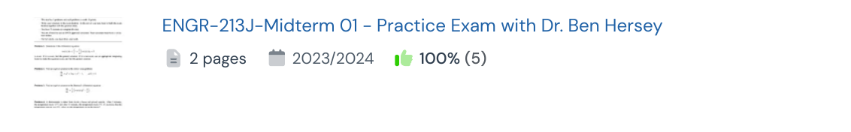
Catalogue source: Practice, page 1

8. Concordia University ENGR 213 Midterm Exam 2 Study Guide
Open on Studocu • document 145715011
Type: Study/review aid | Catalogue pages: 1 | Listed year/date: 2023/2024
Exam date and document contents not independently verified. Inclusion is based on the catalogue title and academic-year label.
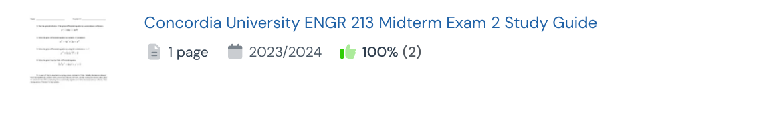
Catalogue source: Practice, page 2

9. Midterm Exam 2 Study Guide for ENGR 213 F23 by Marco Bertola
Open on Studocu • document 87260657
Type: Study/review aid | Catalogue pages: 1 | Listed year/date: 2023/2024
Title says ENGR 213 F23 (Fall 2023), Marco Bertola. Academic year 2023/2024. Exact date and instructor role were not independently visible in extracted header text; catalogue calls it a study guide.
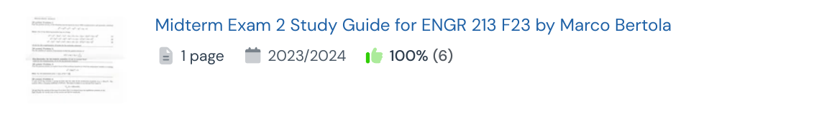
Catalogue source: Practice, page 1

2024
14 listings. Year grouping is a navigation aid; read the evidence note for each entry.

1. ENGR 213 - Term Test 2 - Solutions (Version I)
Open on Studocu • document 112753669
Type: Exam/solutions listing | Catalogue pages: 7 | Listed year/date: 2024/2025
Exam date and document contents not independently verified. Inclusion is based on the catalogue title and academic-year label.
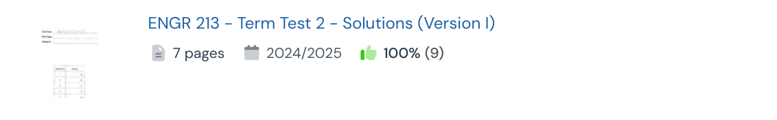
Catalogue source: Practice, page 1

2. ENGR 213 - Term Test 2 Solutions with Detailed Explanations
Open on Studocu • document 113345819
Type: Exam/solutions listing | Catalogue pages: 6 | Listed year/date: 2024/2025
Exam date and document contents not independently verified. Inclusion is based on the catalogue title and academic-year label.
Catalogue source: Practice, page 1

3. ENGR 213 Midterm II Solutions - Differential Equations (Nov 20, 2024)
Open on Studocu • document 112962564
Type: Exam/solutions listing | Catalogue pages: 4 | Listed year/date: 2024/2025
Header checked: ENGR 213 Section V, Midterm II, November 20, 2024. Solutions; 4 pages indicated in viewer. Academic year 2024/2025 is consistent.
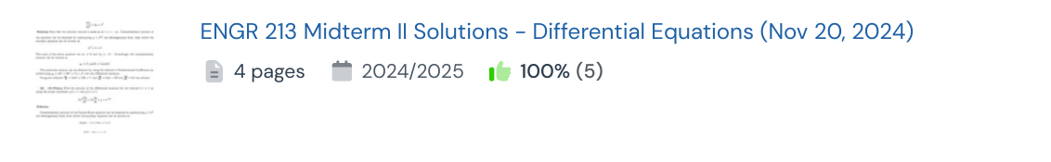
Catalogue source: Practice, page 1

4. ENGR 213 Section V Midterm Solutions - 11th Oct 2024
Open on Studocu • document 148002636
Type: Exam/solutions listing | Catalogue pages: 4 | Listed year/date: 2025/2026
Header checked: ENGR 213 Section V, Midterm, October 11, 2024. Site labels it 2025/2026; that is not the exam year. Viewer indicates 4 pages.
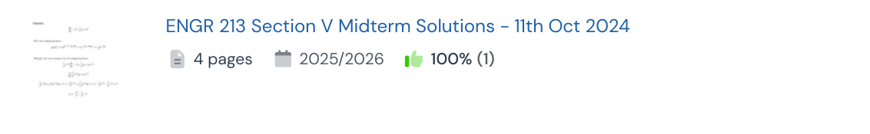
Catalogue source: Practice, page 2

5. Midterm 1 Solutions - Detailed Explanations and Answers
Open on Studocu • document 91514322
Type: Exam/solutions listing | Catalogue pages: 6 | Listed year/date: 2024/2025
Exam date and document contents not independently verified. Inclusion is based on the catalogue title and academic-year label.
Catalogue source: Practice, page 1

6. Midterm 1 Solutions for Differential Equations and Heat Transfer
Open on Studocu • document 111323150
Type: Exam/solutions listing | Catalogue pages: 7 | Listed year/date: 2024/2025
Exam date and document contents not independently verified. Inclusion is based on the catalogue title and academic-year label.
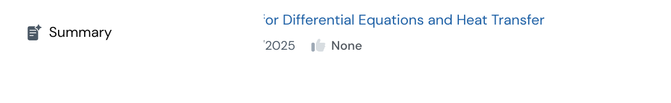
Catalogue source: Other, page 3

7. Midterm 1 Solutions: Differential Equations and Applications
Open on Studocu • document 135664461
Type: Exam/solutions listing | Catalogue pages: 8 | Listed year/date: 2024/2025
Exam date and document contents not independently verified. Inclusion is based on the catalogue title and academic-year label.
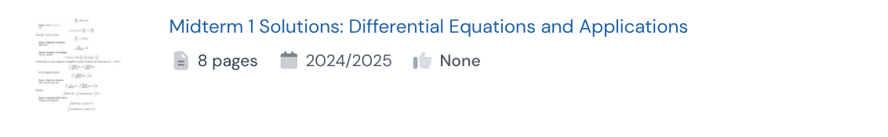
Catalogue source: Practice, page 4

8. Midterm Test 2 Solutions for ENGR 213 Section WA
Open on Studocu • document 112960694
Type: Exam/solutions listing | Catalogue pages: 2 | Listed year/date: 2024/2025
Exam date and document contents not independently verified. Inclusion is based on the catalogue title and academic-year label.
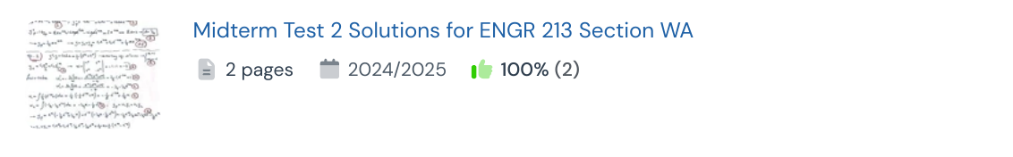
Catalogue source: Other, page 1

9. Midterm 02 - ENGR 213 Applied Ordinary Differential Equations
Open on Studocu • document 110697365
Type: Midterm/term-test listing | Catalogue pages: 1 | Listed year/date: 2024/2025
Exam date and document contents not independently verified. Inclusion is based on the catalogue title and academic-year label.
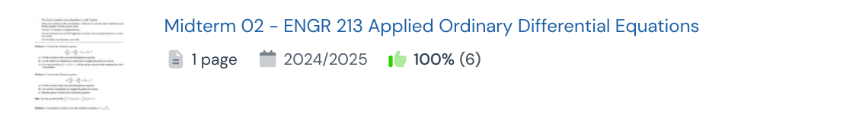
Catalogue source: Practice, page 1

10. Untitled document-4 - midterm
Open on Studocu • document 147674745
Type: Midterm/term-test listing | Catalogue pages: 1 | Listed year/date: 2024/2025
Exam date and document contents not independently verified. Inclusion is based on the catalogue title and academic-year label.
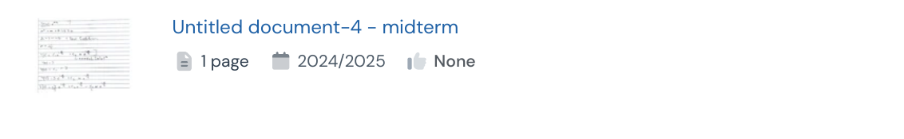
Catalogue source: Other, page 2

11. Untitled document-5 - midterm
Open on Studocu • document 147674785
Type: Midterm/term-test listing | Catalogue pages: 1 | Listed year/date: 2024/2025
Exam date and document contents not independently verified. Inclusion is based on the catalogue title and academic-year label.
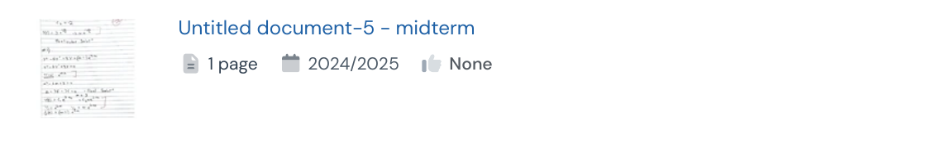
Catalogue source: Other, page 2

12. Test 1 - Midterm Sample 2024: ODEs & Complex Numbers Solutions
Open on Studocu • document 144106363
Type: Practice/sample | Catalogue pages: 1 | Listed year/date: 2023/2024
Exam date and document contents not independently verified. Inclusion is based on the catalogue title and academic-year label.
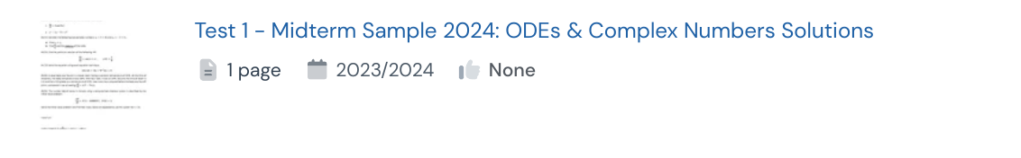
Catalogue source: Practice, page 4

13. ENGR 213 Midterm 1 Study Guide: Initial Value Problems Explained
Open on Studocu • document 118207562
Type: Study/review aid | Catalogue pages: 3 | Listed year/date: 2024/2025
Exam date and document contents not independently verified. Inclusion is based on the catalogue title and academic-year label.
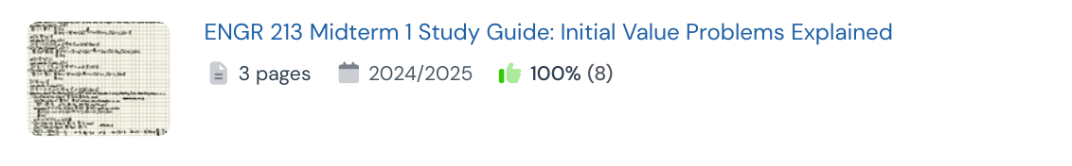
Catalogue source: Practice, page 1

14. Midterm 2 Study Guide for Course 213
Open on Studocu • document 114069680
Type: Study/review aid | Catalogue pages: 2 | Listed year/date: 2024/2025
Exam date and document contents not independently verified. Inclusion is based on the catalogue title and academic-year label.
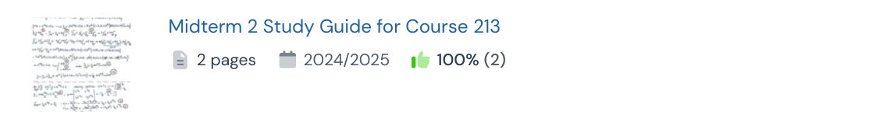
Catalogue source: Practice, page 2

2025
11 listings. Year grouping is a navigation aid; read the evidence note for each entry.

1. ENGR 213 Midterm 2 Solutions and Explanations
Open on Studocu • document 159659013
Type: Exam/solutions listing | Catalogue pages: 8 | Listed year/date: 2025/2026
Exam date and document contents not independently verified. Inclusion is based on the catalogue title and academic-year label.
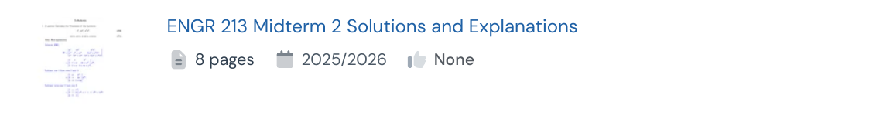
Catalogue source: Practice, page 4

2. ENGR 213 XX Fall 2025 Term Test 1 Solutions
Open on Studocu • document 147809123
Type: Exam/solutions listing | Catalogue pages: 8 | Listed year/date: 2025/2026
Exam date and document contents not independently verified. Inclusion is based on the catalogue title and academic-year label.
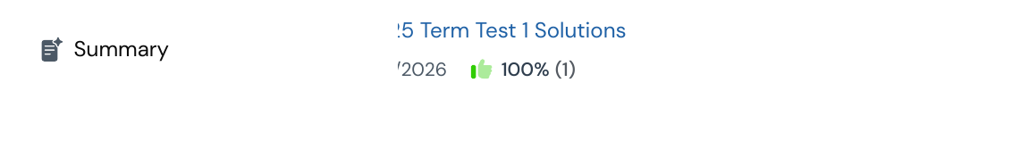
Catalogue source: Practice, page 3

3. Midterm 1 Solutions for ODEs - Course 213
Open on Studocu • document 147782462
Type: Exam/solutions listing | Catalogue pages: 8 | Listed year/date: 2025/2026
Exam date and document contents not independently verified. Inclusion is based on the catalogue title and academic-year label.
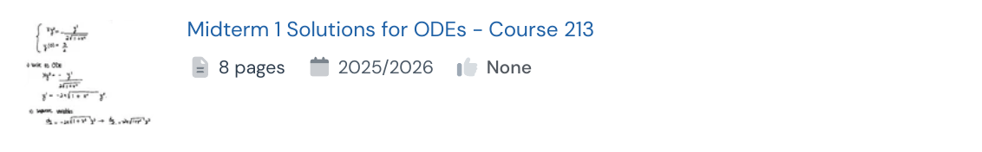
Catalogue source: Practice, page 4

4. Midterm Exam: IVP Solutions & ODE Analysis (Course Code: 2025)
Open on Studocu • document 147674594
Type: Exam/solutions listing | Catalogue pages: 1 | Listed year/date: 2024/2025
Exam date and document contents not independently verified. Inclusion is based on the catalogue title and academic-year label.
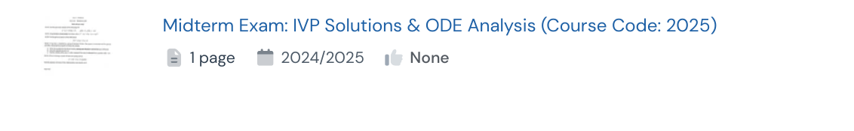
Catalogue source: Other, page 2

5. 2025 Midterm Fall
Open on Studocu • document 141916505
Type: Midterm/term-test listing | Catalogue pages: 1 | Listed year/date: 2025/2026
Signed-in viewer header visually checked: ENGR 213, Monday October 6, Sections RA/RB; instructor Alexey Kokotov; 1 hour, closed book. Header does not print the year; title says Fall 2025 and metadata says 2025/2026. Catalogue lists 1 page.
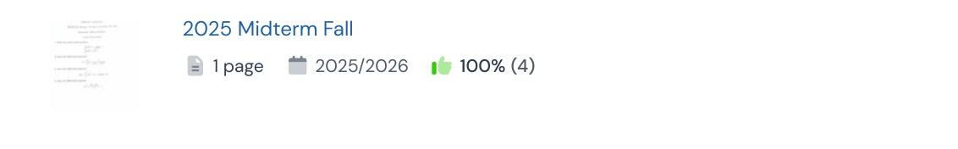
Catalogue source: Practice, page 1

6. ENGR 213 Applied Ordinary Differential Equations Midterm Exam 1
Open on Studocu • document 145750039
Type: Midterm/term-test listing | Catalogue pages: 6 | Listed year/date: 2025/2026
Exam date and document contents not independently verified. Inclusion is based on the catalogue title and academic-year label.
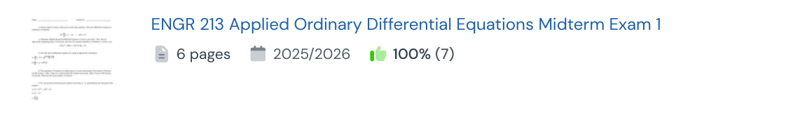
Catalogue source: Other, page 1

7. ENGR 213 Midterm Exam 1: Applied Ordinary Differential Equations
Open on Studocu • document 142038946
Type: Midterm/term-test listing | Catalogue pages: 1 | Listed year/date: 2025/2026
Exam date and document contents not independently verified. Inclusion is based on the catalogue title and academic-year label.
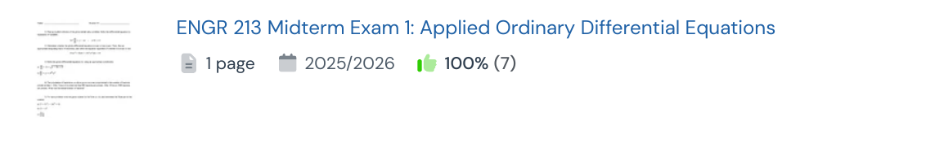
Catalogue source: Practice, page 1

8. ENGR 213 Midterm II: Homogeneous ODEs & Initial Value Problems
Open on Studocu • document 153567804
Type: Midterm/term-test listing | Catalogue pages: 3 | Listed year/date: 2025/2026
Exam date and document contents not independently verified. Inclusion is based on the catalogue title and academic-year label.
Catalogue source: Practice, page 1

9. ENGR 213 Midterm Exam Sample Solutions and Notes
Open on Studocu • document 153567238
Type: Practice/sample | Catalogue pages: 4 | Listed year/date: 2025/2026
Exam date and document contents not independently verified. Inclusion is based on the catalogue title and academic-year label.
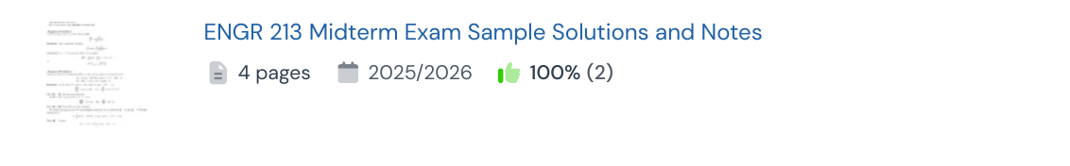
Catalogue source: Practice, page 2

10. Practice Midterm 1: ODE Solutions & Population Models
Open on Studocu • document 148613205
Type: Practice/sample | Catalogue pages: 1 | Listed year/date: 2025/2026
Exam date and document contents not independently verified. Inclusion is based on the catalogue title and academic-year label.
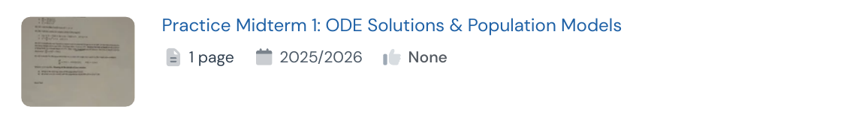
Catalogue source: Practice, page 4

11. ODE Cheat Sheet - Midterm 1 & 2 Review Guide
Open on Studocu • document 145845673
Type: Study/review aid | Catalogue pages: 8 | Listed year/date: 2025/2026
Exam date and document contents not independently verified. Inclusion is based on the catalogue title and academic-year label.
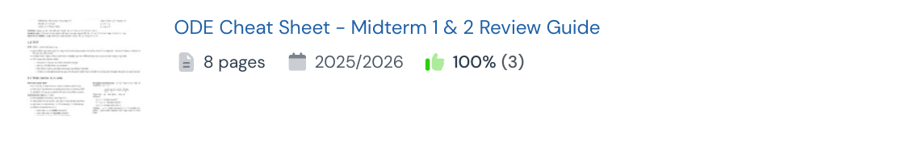
Catalogue source: Practice, page 2

2026
4 listings. Year grouping is a navigation aid; read the evidence note for each entry.

1. ENGR 213 JB Term Test 1 Solutions - March 20, 2026
Open on Studocu • document 157019040
Type: Exam/solutions listing | Catalogue pages: 10 | Listed year/date: 2026/2027
Header checked: ENGR 213 JB Term Test 1, Version 2, March 20, 2026. Site academic-year label 2026/2027 conflicts with the March 2026 date. Catalogue lists 10 pages.
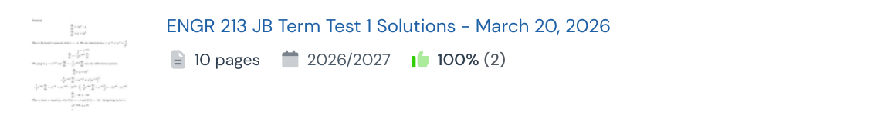
Catalogue source: Practice, page 2

2. Engr 213 Midterm 1 Solutions & Steps - Winter 2026
Open on Studocu • document 155695697
Type: Exam/solutions listing | Catalogue pages: 1 | Listed year/date: 2026/2027
Title identifies Winter 2026 solutions; site academic-year label is 2026/2027. Exact exam date and instructor not verified. Catalogue lists 1 page, so do not assume it is a complete exam.
Catalogue source: Practice, page 1

3. Midterm Exam Solutions for ENGR 213 - Applied Differential Equations 2026
Open on Studocu • document 159567841
Type: Exam/solutions listing | Catalogue pages: 6 | Listed year/date: 2026/2027
Exam date and document contents not independently verified. Inclusion is based on the catalogue title and academic-year label.
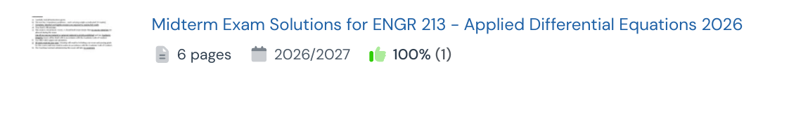
Catalogue source: Practice, page 2

4. Midterm Test 2 Solutions for ENGR 213: Applied Differential Equations
Open on Studocu • document 159831541
Type: Exam/solutions listing | Catalogue pages: 7 | Listed year/date: 2026/2027
Exam date and document contents not independently verified. Inclusion is based on the catalogue title and academic-year label.
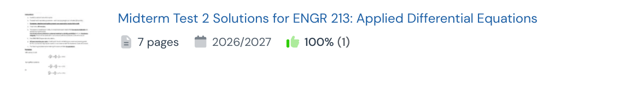
Catalogue source: Practice, page 2

Undated lead
1 listings. Year grouping is a navigation aid; read the evidence note for each entry.

1. ENGR 213 Applied Ordinary Differential Equations - Summer Midterm
Open on Studocu • document 165845772
Type: Midterm/term-test listing | Catalogue pages: 11 | Listed year/date: not shown
Exam date and document contents not independently verified. Inclusion is based on the catalogue title and academic-year label.
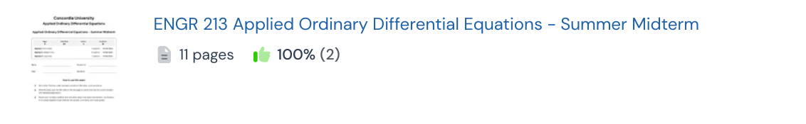
Catalogue source: Practice, page 2

Sources and methodology
Practice materials, page 1
Practice materials, page 2
Practice materials, page 3
Practice materials, page 4
Practice materials, page 5
Practice materials, page 6
Practice materials, page 7
Practice materials, page 8
Other Documents, page 1
Other Documents, page 2
Other Documents, page 3
Other Documents, page 4
Individual document links throughout this report are the sources for entries. Catalogue metadata was read in the browser. Selected date/header checks were made on the linked viewer pages; unchecked fields are explicitly labelled.

Excluded leads
Excluded on visible title or clearly out-of-range metadata; not every excluded document was opened.
ENGR 233-S Midterm 1 Solutions and Explanations — Different course indicated by title (ID 108155036)
ENGR 213 Midterm Test 2 Solutions - November 2014 Exam — Exam title dates it before 2018 (ID 202559)
ENGR 213 Midterm Exam 1 Sample Problems and Solutions — Catalogue year before requested period (ID 22715473)
Midterm Exam 1 Questions & Solutions for ENGR-213-Fall 2017 — Exam title dates it before 2018 (ID 2908766)
ENGR 213 Midterm Exam I Solutions - Winter 2016 — Exam title dates it before 2018 (ID 149464199)
ENGR213 Midterm Exam 1 Study Guide - Fall 2017 — Exam title dates it before 2018 (ID 60830202)
ENGR 213: Midterm Test 1 Solutions and Answer Key, Fall 2014 — Exam title dates it before 2018 (ID 202562)
Midterm Exam Solutions for ENGR 213/2 (08-F) - October 2008 — Exam title dates it before 2018 (ID 119717760)
Midterm I Review Questions for ENGR 213 - October 2012 — Exam title dates it before 2018 (ID 1113149)
Sample Midterm 2017 — Exam title dates it before 2018 (ID 141122859)
Midterm Exam (07-W): Engineering Differential Equations Solutions — Catalogue year before requested period (ID 119717744)
Midterm Solutions for Differential Equations - MATH 201 Nov 15 — Different course indicated by title (ID 113141779)
Midterm 1 Review Problems, ENG 213, Winter 2017 — Exam title dates it before 2018 (ID 144607136)
MATH 370 Midterm Exam Practice Problems - October 2019 — Different course indicated by title (ID 142475831)
Midterm 2 EMAT 213 Winter 2006 Practice Problems & Solutions — Exam title dates it before 2018 (ID 120092478)
Midterm Exam Notes for Applied Ordinary Differential Equations (ENGR 213) — Catalogue year before requested period (ID 119717751)
Midterm Exam Notes for Engineering 213 - November 22, 2010 — Exam title dates it before 2018 (ID 119717746)
Midterm Exam II: Applied Ordinary Differential Equations (ENGR 213) — Catalogue year before requested period (ID 119717742)
Midterm 1 Sample — Catalogue year before requested period (ID 60830189)
ENGR 213 - February 2010 Midterm Solutions and Explanations — Exam title dates it before 2018 (ID 22767848)
ENGR 213 Sample Midterm Exam: Applied Ordinary Differential Equations — Catalogue year before requested period (ID 22715461)
ENGR 213: 1st Midterm Exam Solutions - Differential Equations (Oct 2014) — Exam title dates it before 2018 (ID 167745)
Midterm 1A Practice Problems for ENGR 213 - October 2015 — Exam title dates it before 2018 (ID 142475796)
Midterm 2 Solutions for Differential Equations (MATH 301) — Different course indicated by title (ID 135664457)
Midterm Solutions for Thermodynamics (Course Code: T Crcl T) — Different course indicated by title (ID 134578304)
EMAT213 Fall 2005 - Midterm Exam Practice Problems & Solutions — Exam title dates it before 2018 (ID 120092463)
Midterm Exam Solutions for Linear ODEs (Course 05-F) — Catalogue year before requested period (ID 119717740)
Midterm Exam Review for ENGR 213: Applied Ordinary Differential Equations — Catalogue year before requested period (ID 119717738)
Midterm Exam Solutions for ODEs (06-W) - March 2006 — Exam title dates it before 2018 (ID 119717737)
2015 Fall Midterm with solutions — Exam title dates it before 2018 (ID 54578715)
2017 Winter Midterm Exam Solutions and Key Insights — Exam title dates it before 2018 (ID 54578871)
ENGR 213 Winter 2016 Midterm Exam II - Applied ODE Solutions — Exam title dates it before 2018 (ID 42890265)
Review Problems - EMAT 213 Midterm Exam Paper — Catalogue year before requested period (ID 42522664)
Sample Midterm 1 2007 — Exam title dates it before 2018 (ID 24854056)
ENGR 213 - Midterm 1 Questions & Solutions - Fall 2005 — Exam title dates it before 2018 (ID 20344134)
2016 Winter B Midterm Problem Set Solutions — Exam title dates it before 2018 (ID 12740145)
ENGR 213 - Midterm Test I Solutions | Applied ODEs | Oct 6, 2008 — Exam title dates it before 2018 (ID 9923580)
Midterm Exam II ENGR 213: Applied Ordinary Differential Equations — Catalogue year before requested period (ID 6064999)
Midterm Exam I Answers for ENGR 213 - Applied Differential Equations — Catalogue year before requested period (ID 3904934)
ENGR 312 P: Midterm 2 Sample B for Applied Differential Equations — Different course indicated by title (ID 51197192)
ENGR 213 Midterm Exam II 2016 - Solutions to Differential Equations — Exam title dates it before 2018 (ID 23749526)
Midterm 13-F — Catalogue year before requested period (ID 77488819)
COMP 228 Midterm Exam Notes - February 2012 — Different course indicated by title (ID 26344113)
ENGR 213 Midterm Exam II Winter 2016: Solutions to Key Problems — Exam title dates it before 2018 (ID 23749524)

